**Emergency Management Network**

The Emergency Management Network is an innovative and robust system designed to enhance emergency response efficiency by creating a centralized platform for emergency calls. The system streamlines the process of reporting emergencies by allowing users to call a single designated emergency number (e.g., 119, 1122, 15). The incoming calls are then routed through a central server that intelligently forwards the information to the relevant emergency response agencies, ensuring a swift and coordinated response.

**Key Features:**

1. **Single Point of Contact:**

Users can dial a single emergency number, simplifying the reporting process and reducing confusion during critical situations.

1. **Centralized Server:**

All emergency calls are directed to a centralized server, which acts as the nerve center of the Emergency Management Network.

1. **Intelligent Call Routing:**

The server employs advanced algorithms to analyze the nature and location of the emergency, ensuring accurate and swift routing to the appropriate emergency response agency (e.g., fire department, police, medical services).

1. **Multi-Agency Collaboration:**

Enables seamless communication and coordination among different emergency response agencies, fostering a collaborative and unified approach to crisis management.

1. **Real-time Data Sharing:**

The server facilitates real-time data sharing between emergency services, ensuring that responders have up-to-date information on the unfolding situation.

**Benefits:**

**Faster Response Times:**

The streamlined process ensures that emergency calls are quickly and accurately directed to the appropriate response teams.

**Improved Coordination:**

Enhanced communication and collaboration among response agencies lead to a more cohesive and effective emergency management strategy.

**Increased Public Safety:** The system's efficiency contributes to the overall safety of the community by minimizing response delays and optimizing resource allocation.

**Data-Driven Decision Making**: Historical data analysis provides valuable insights for optimizing emergency response protocols and resource allocation.

In short, ***The Emergency Management Network*** represents a significant advancement in crisis response systems.

***DHCP, VTP, HTTP, RIP Protocol,*** and ***NAT*** are being applied in the network.

In summary, RIP aids in routing decisions, VTP manages VLAN configurations, DHCP automates IP address assignment, HTTP facilitates web communication, and NAT enables the sharing of a single public IP address among multiple devices in a network. These protocols collectively contribute to the e***fficient functioning*** and ***management*** of a network.

**BREAKING DOWN THE NETWORK**

**Whole Network (Emergency Management Network)**

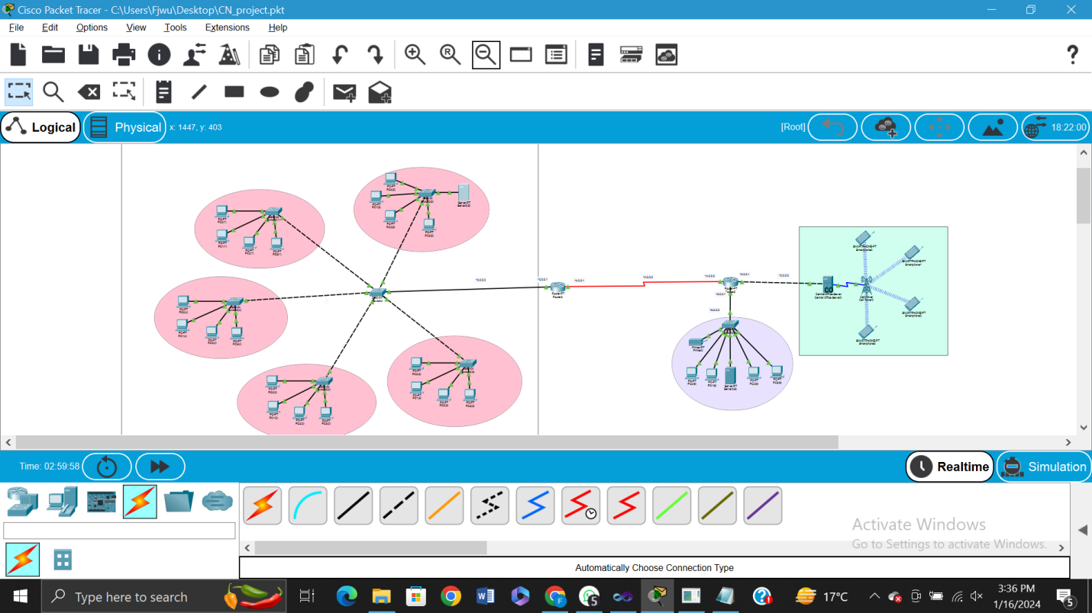

**Real-Time Example:**

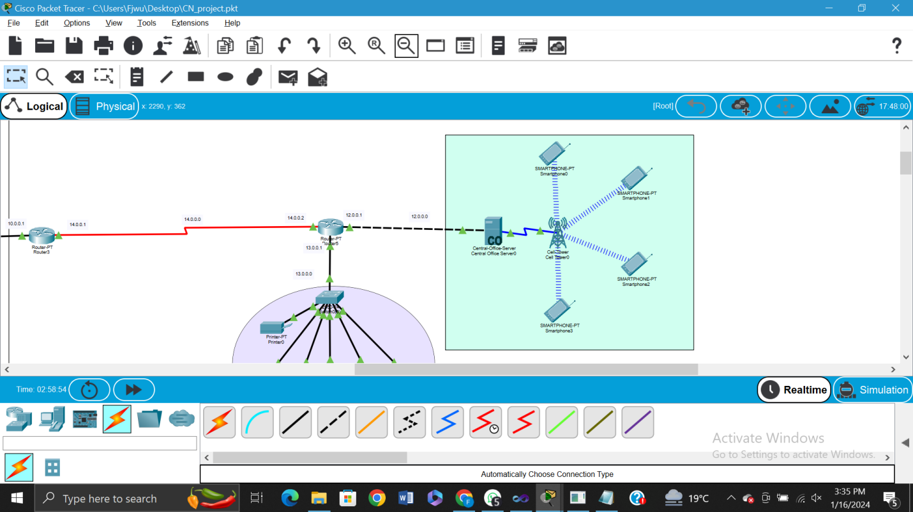

**Small Network Example:**

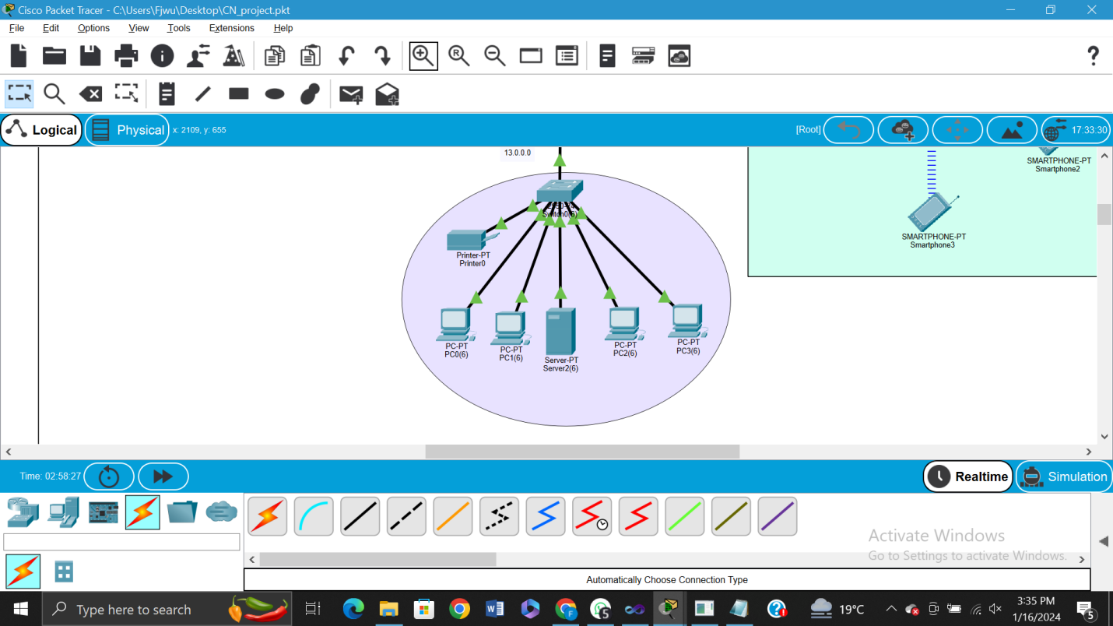

**Network IPs:**

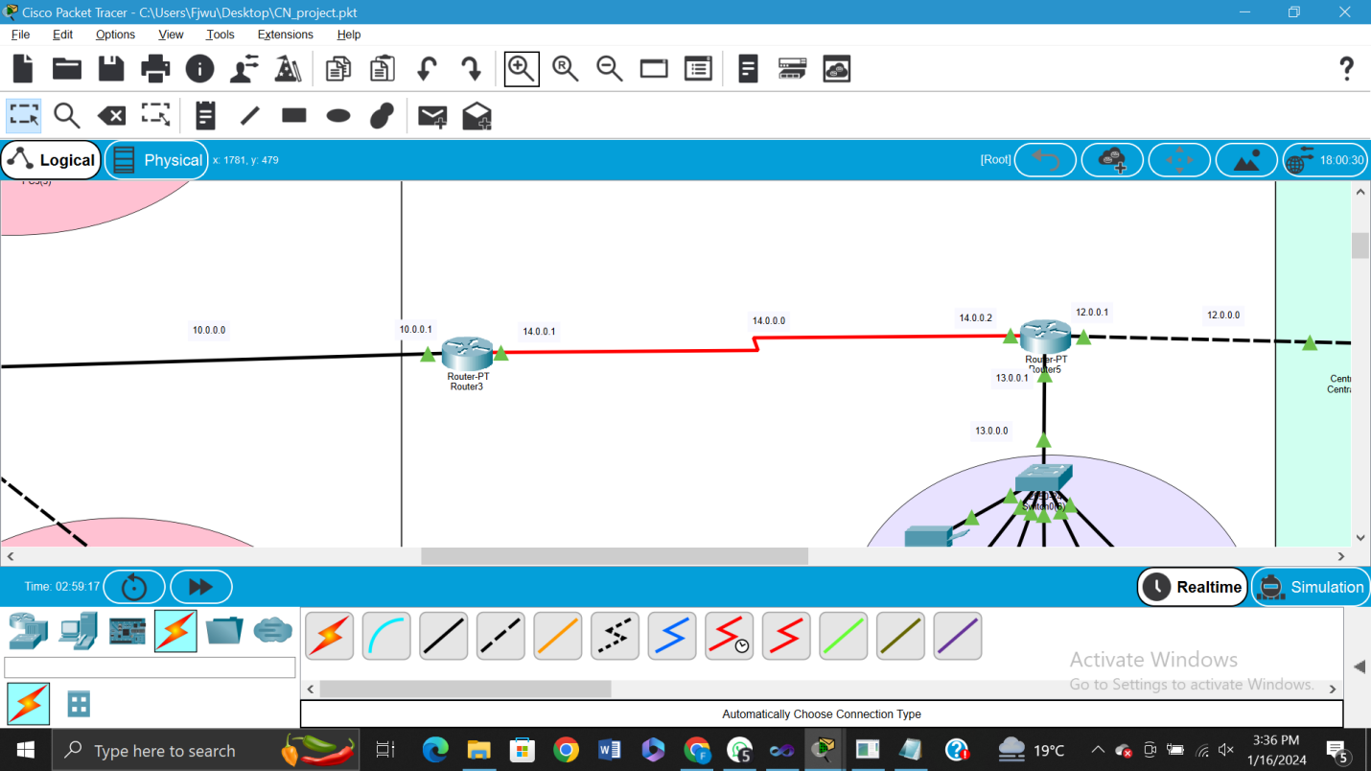

**DHCP on Server:**

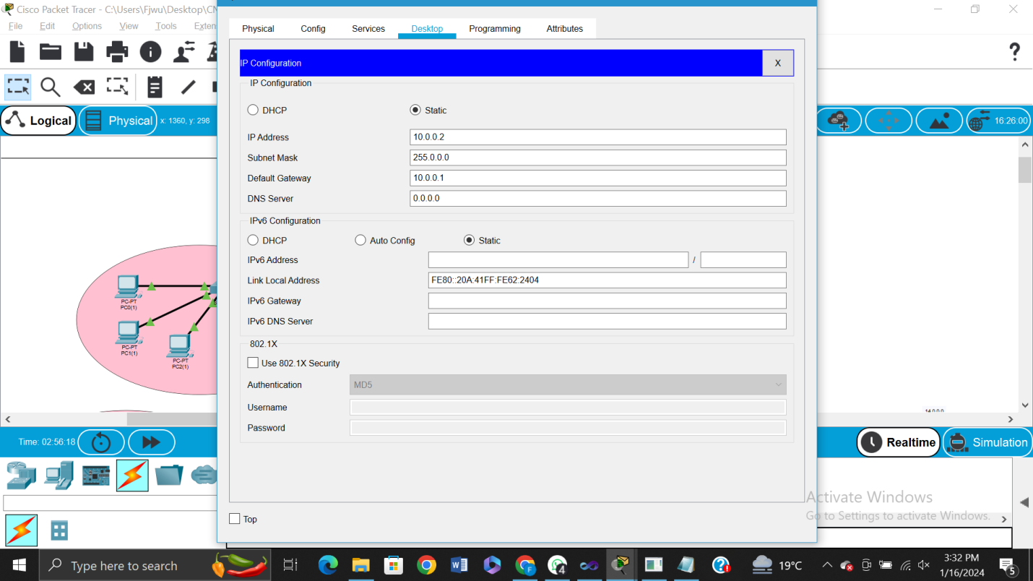

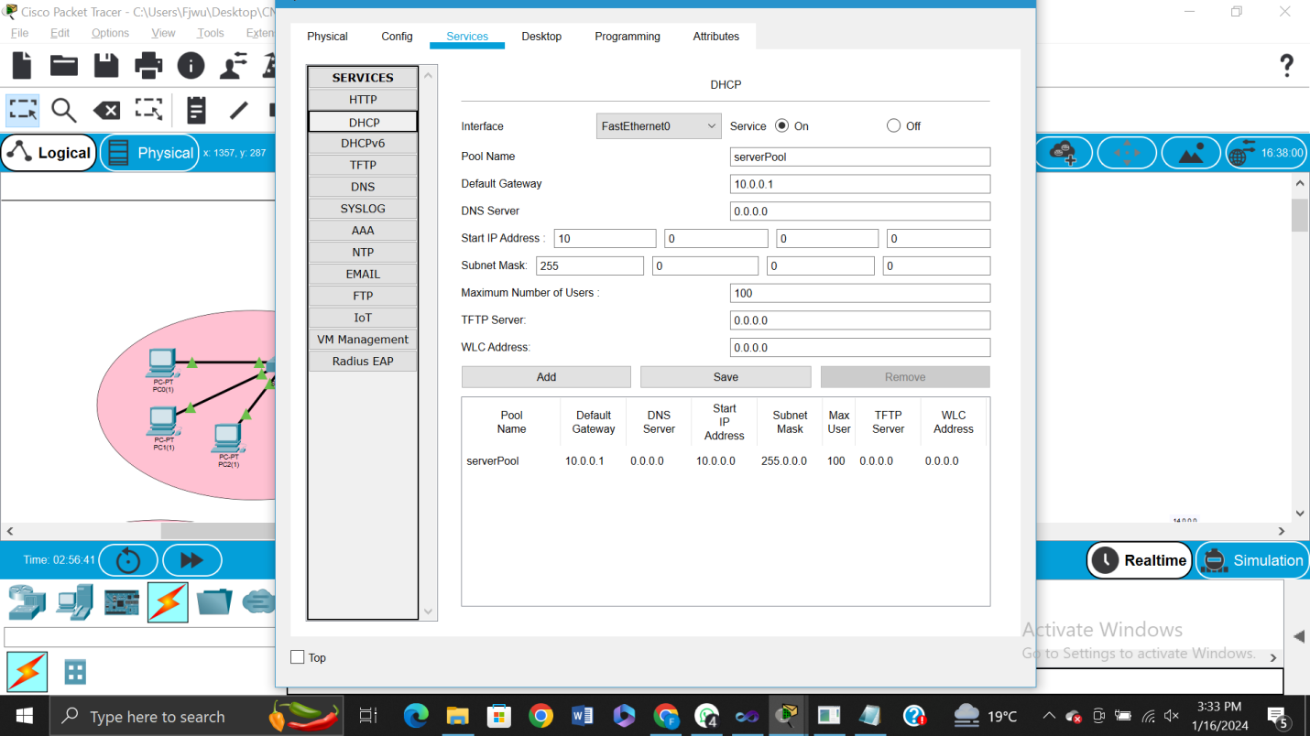

**DHCP on Client:**

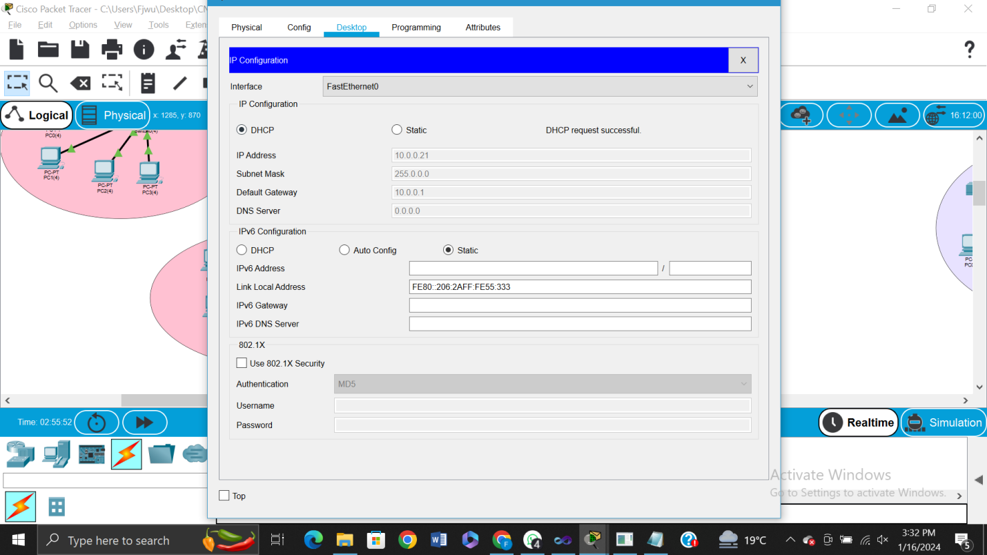

**PINGING WITHIN NETWORK**

**Pinging within the Network 10.0.0.0**

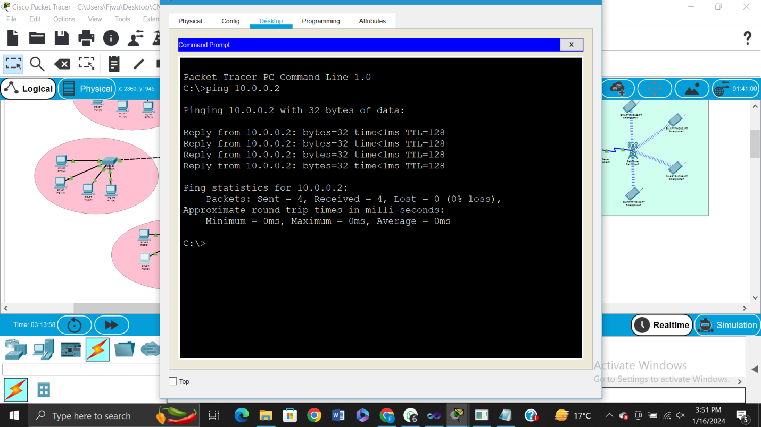

**Pinging within the Network 13.0.0.0**

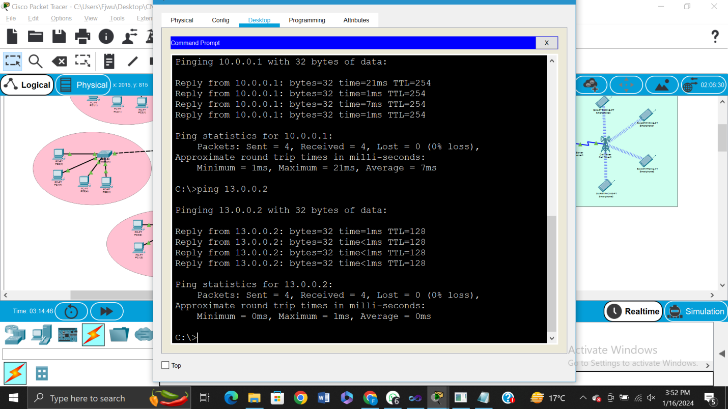

**HTTP**

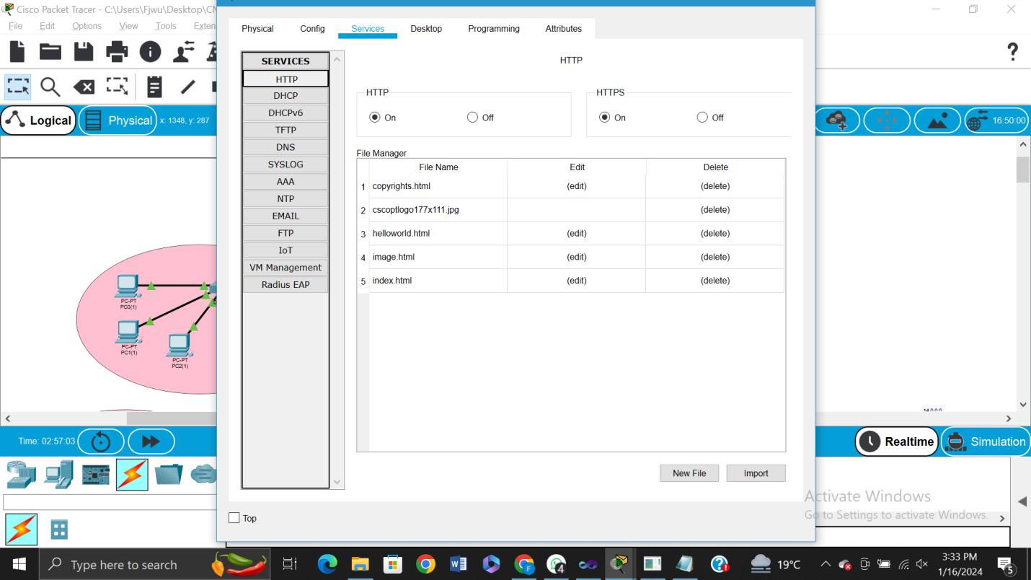

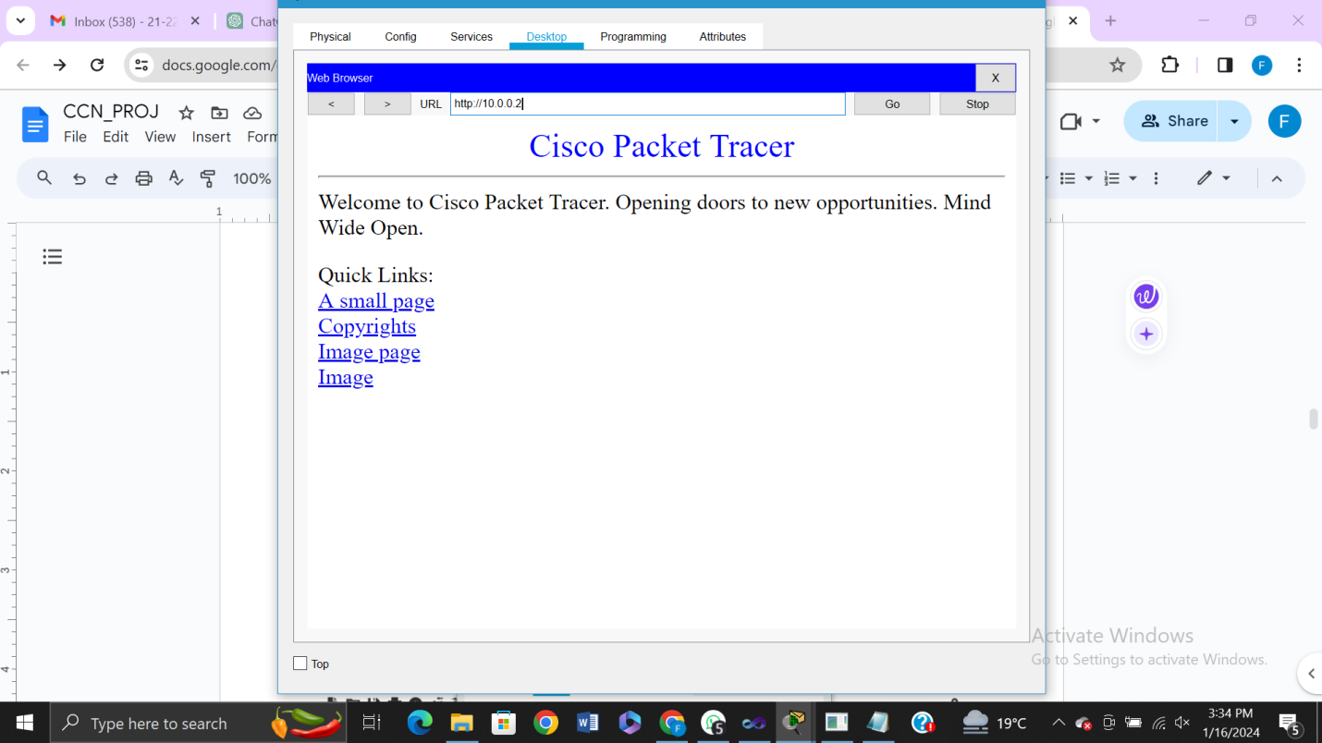

**VTP**

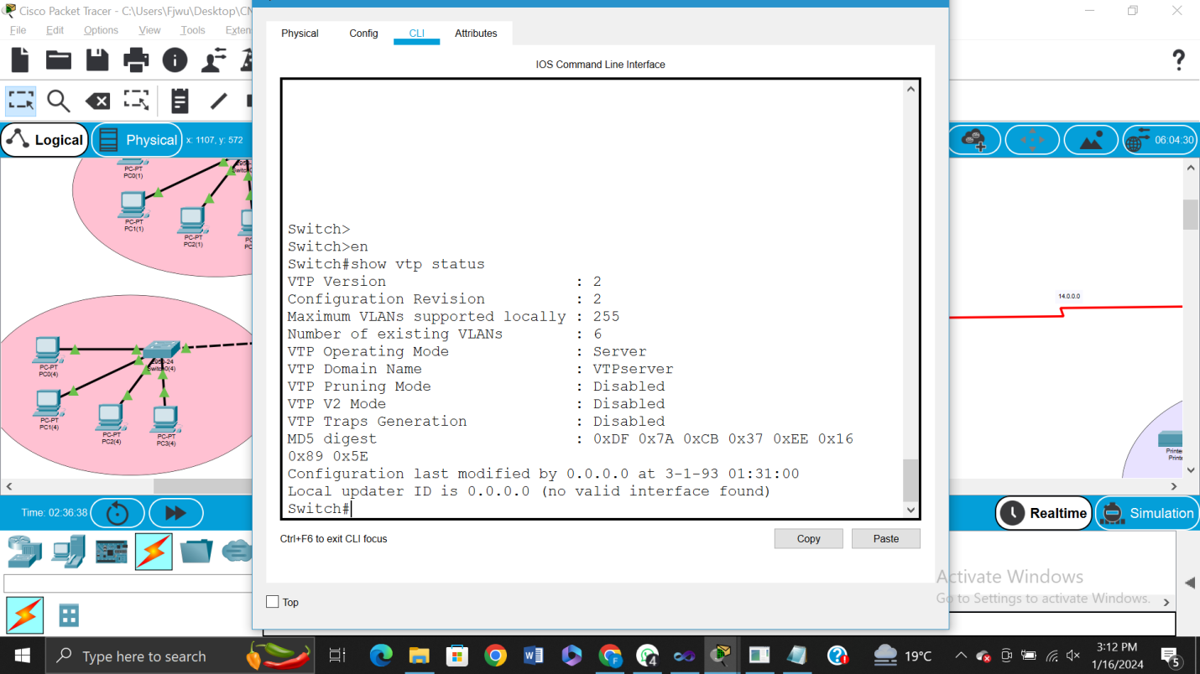

**VTP CLIENTS:**

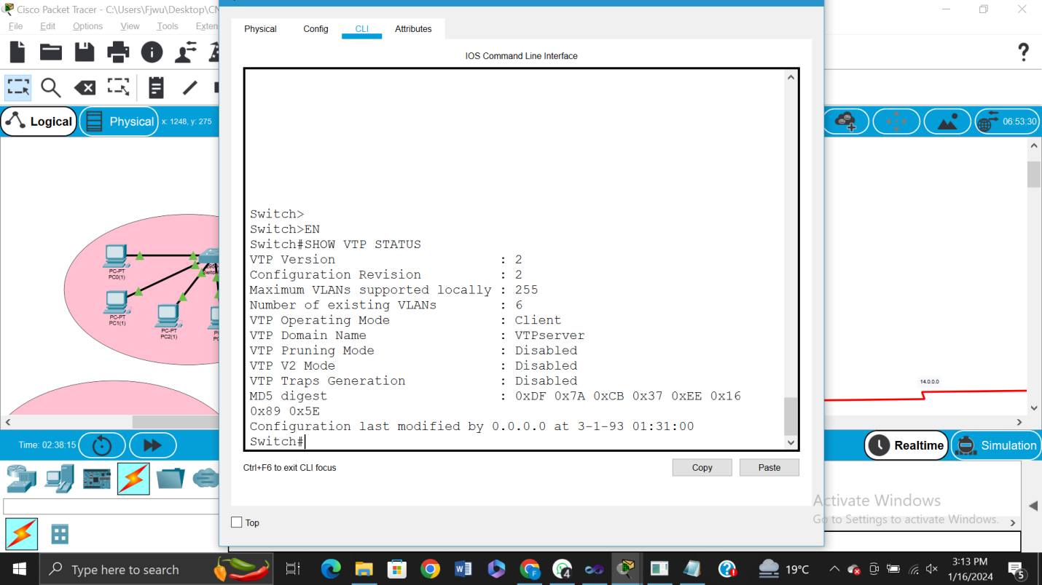

**ONE VLAN was created, that's why it has 6 VLAN.**

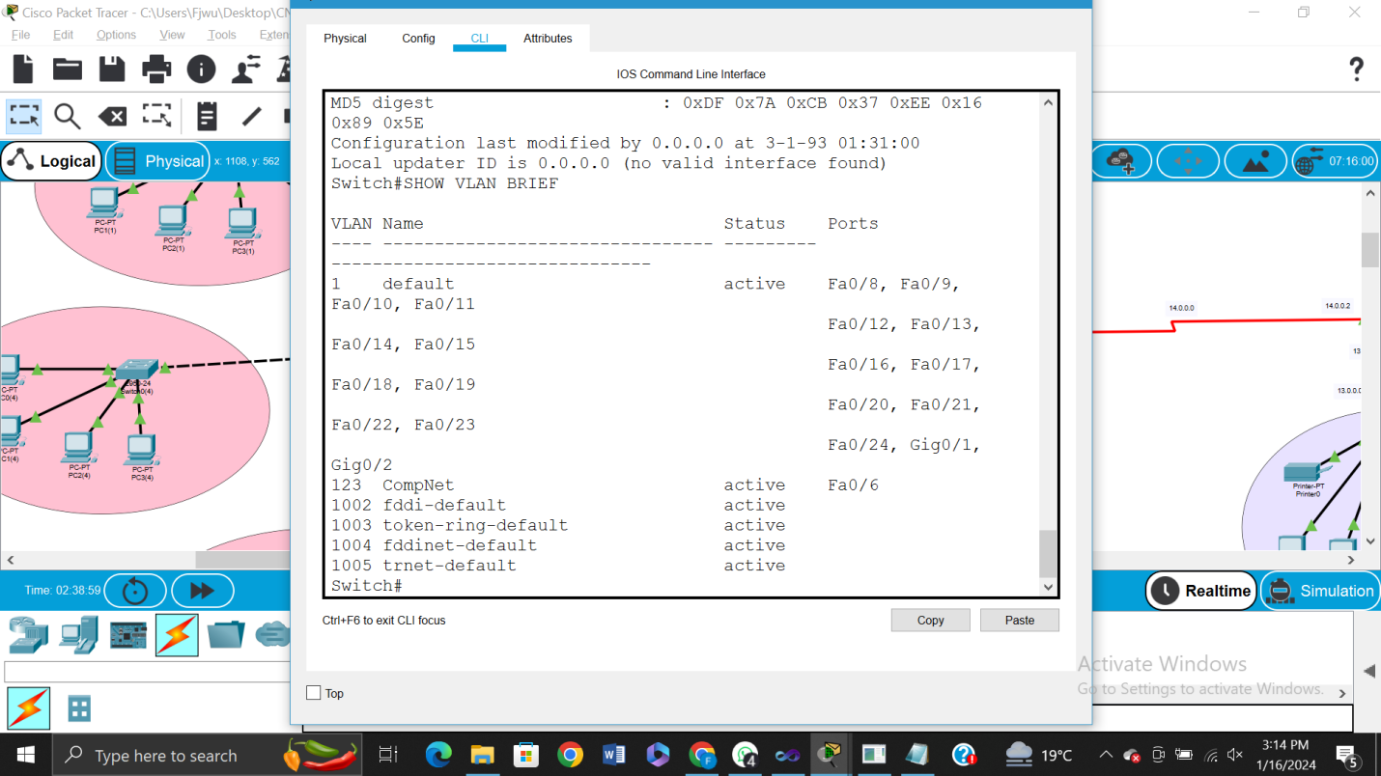

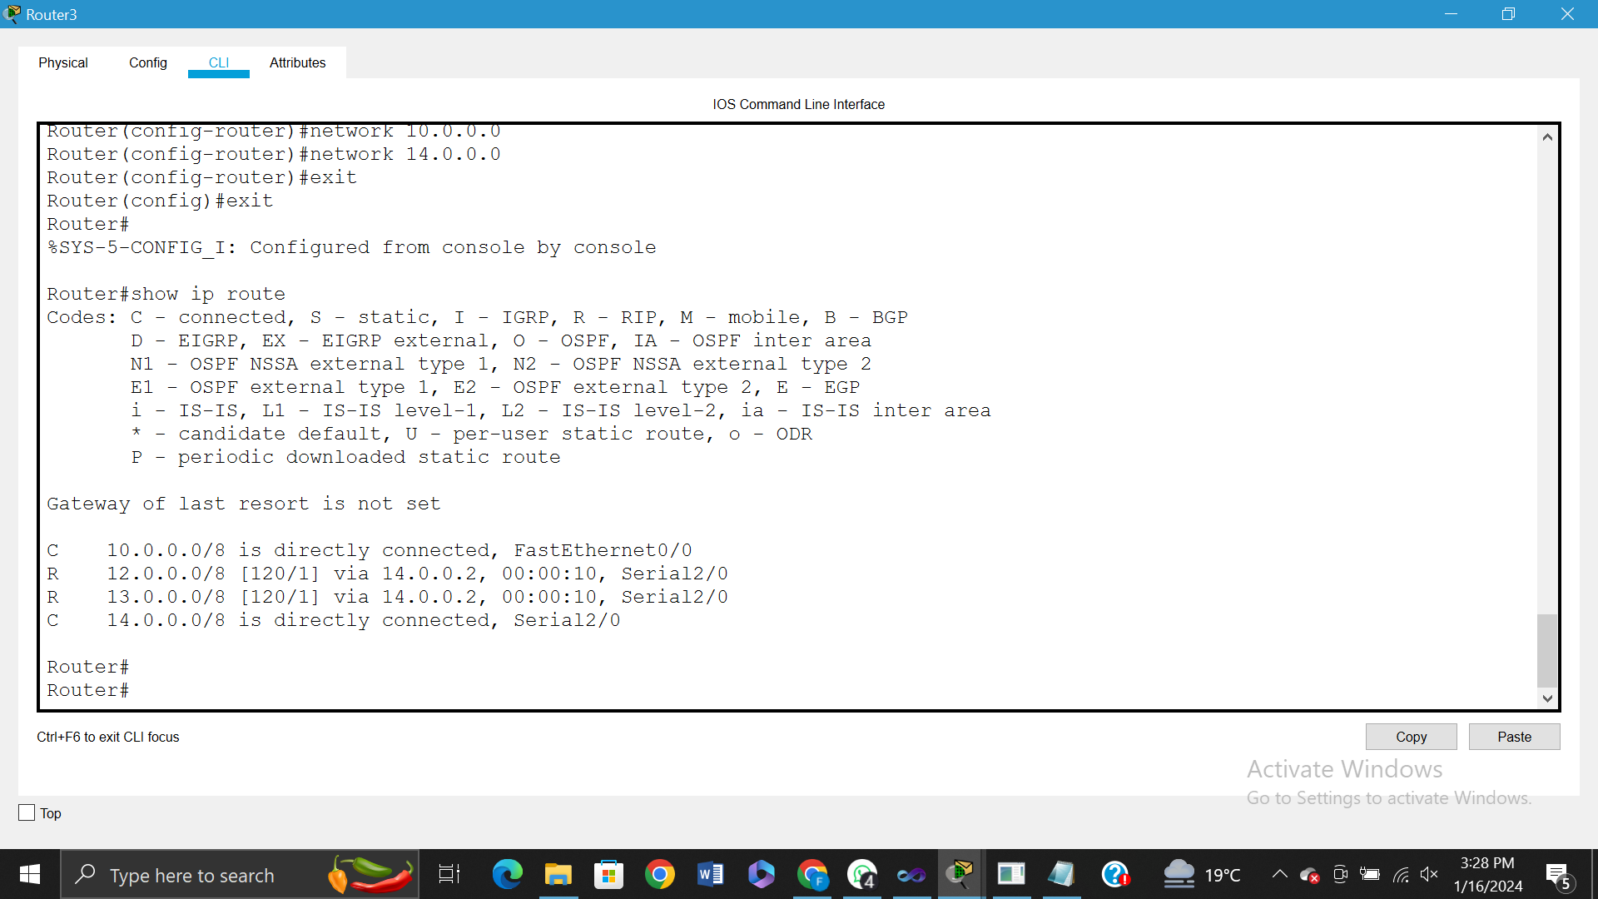

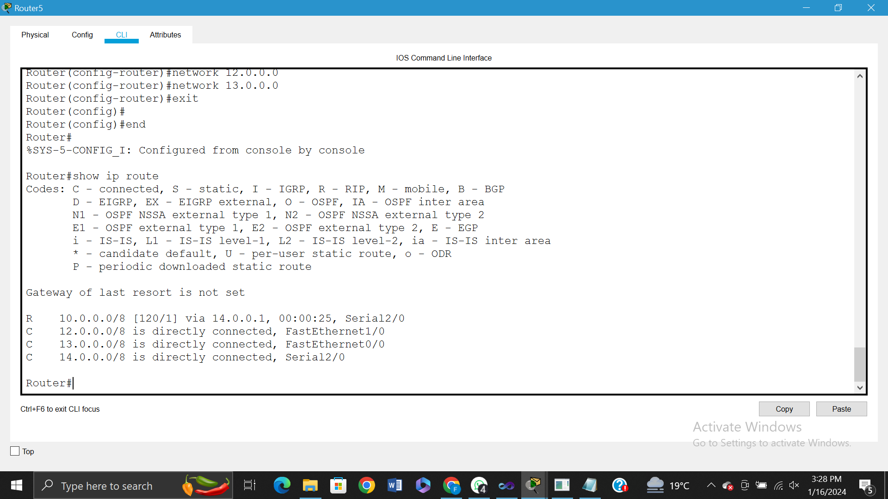

**RIP Protocol**

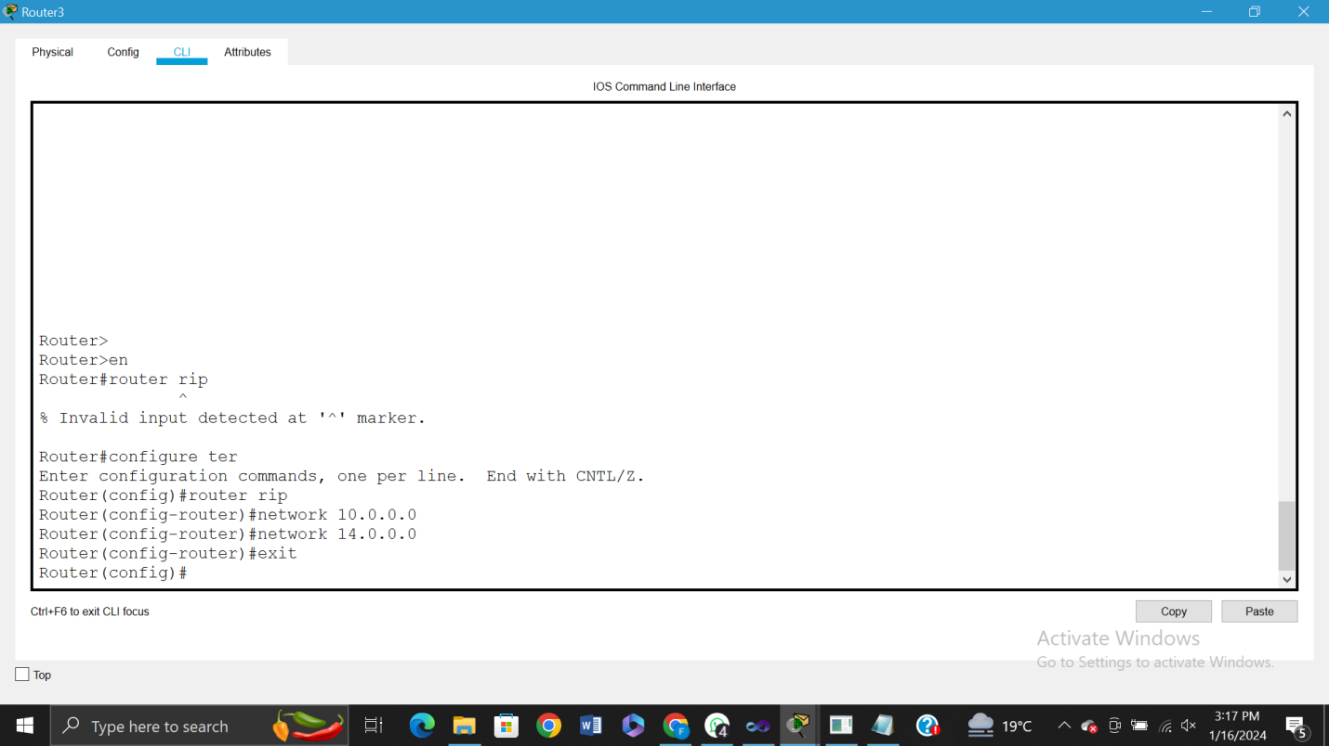

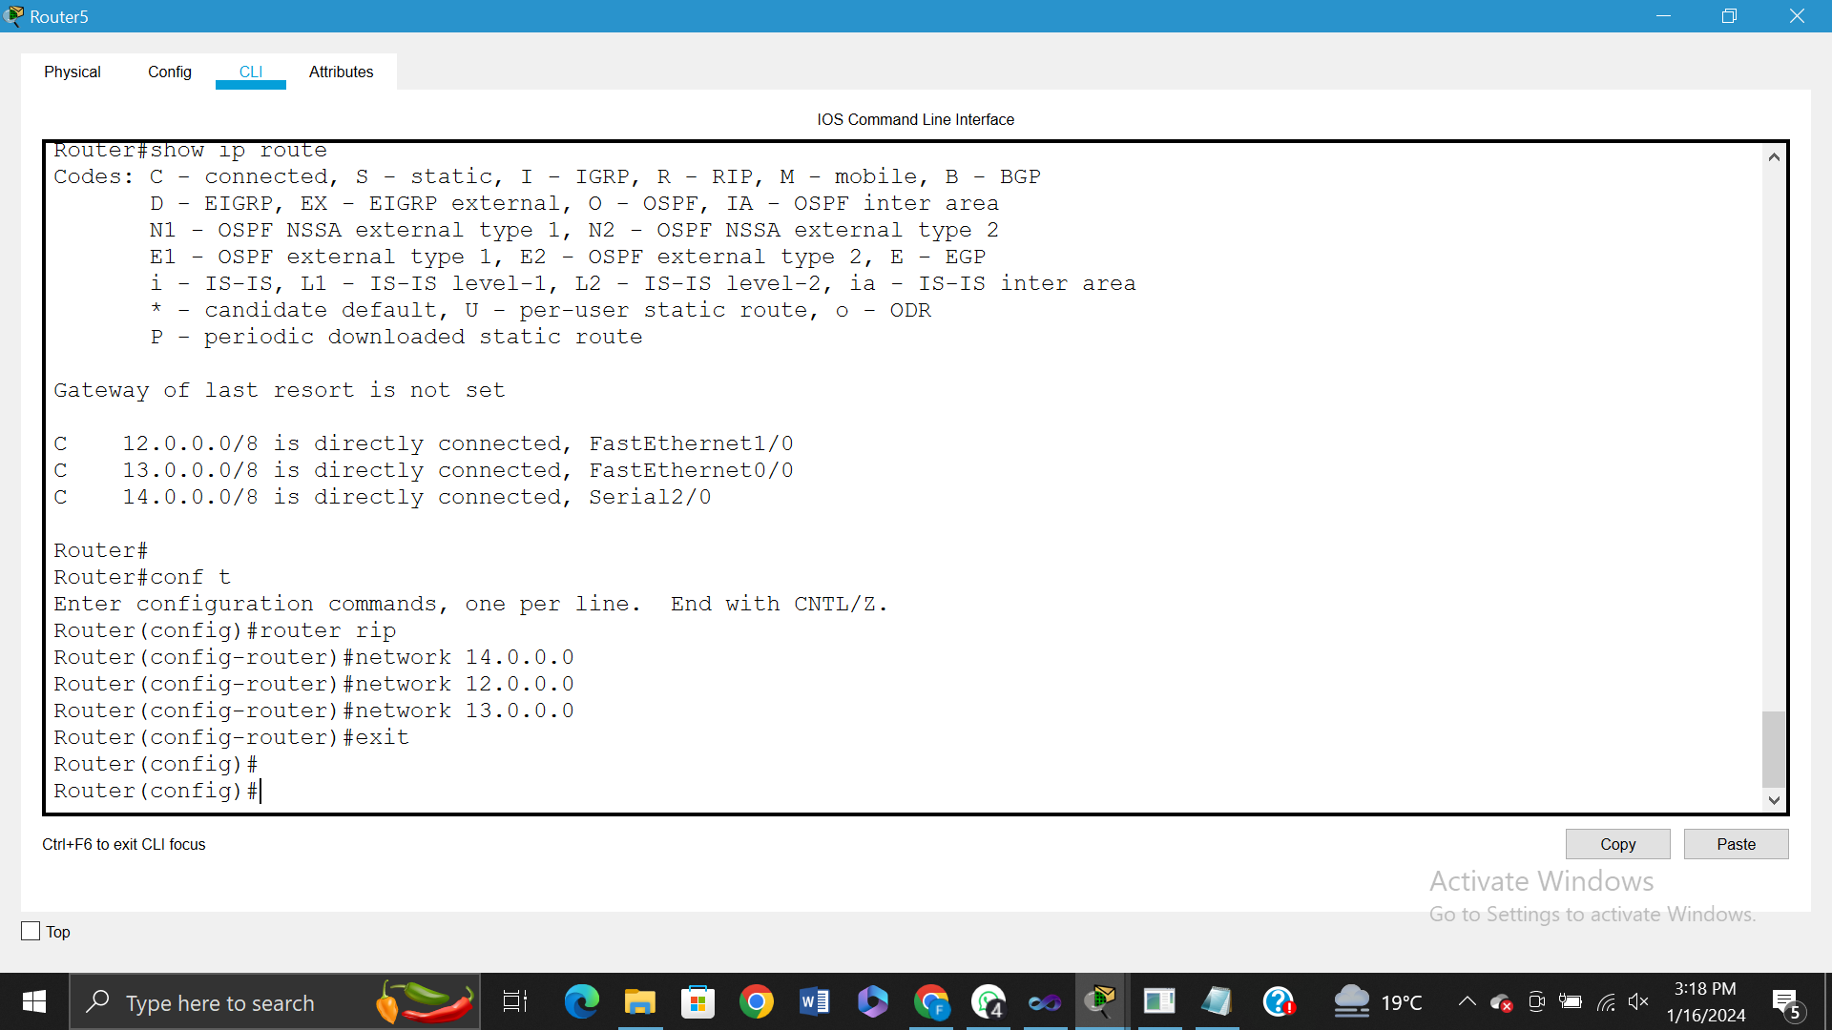

**PINGING OUTSIDE THE NETWORK**

**PINGING from Network 10.0.0.0 to Network 13.0.0.0 and 14.0.0.0.**

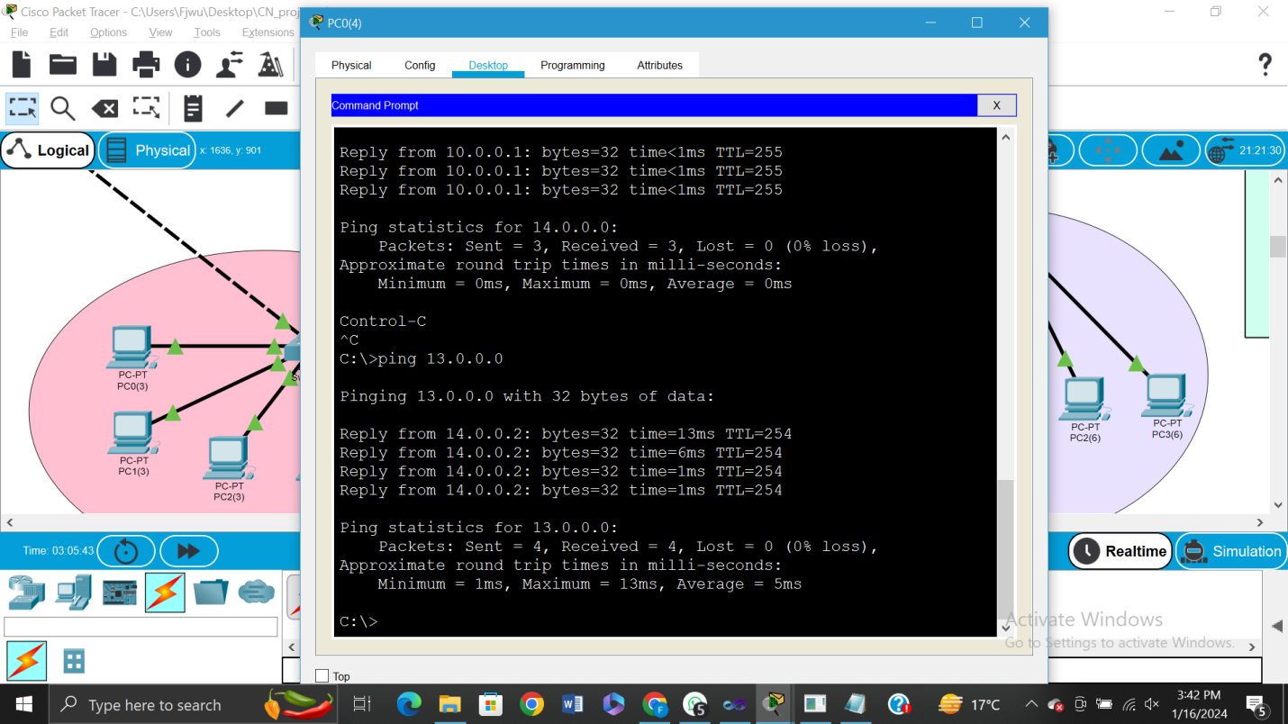

**PINGING from Network 13.0.0.0 to Network 10.0.0.0**

